**S.Jahnavi**

**192011242**

**Program 1**

import java.io.*;

public class Test {

public static void main(String[] args)

throws IOException

{

File file = new File("C:\\Users\\VISHNU VARDHAN\\Documents\\text.txt");

FileInputStream fileInputStream = new FileInputStream(file);

InputStreamReader inputStreamReader = new InputStreamReader(fileInputStream);

BufferedReader bufferedReader = new BufferedReader(inputStreamReader);

String line;

int wordCount = 0;

int characterCount = 0;

int paraCount = 0;

int whiteSpaceCount = 0;

int sentenceCount = 0;

while ((line = bufferedReader.readLine()) != null) {

if (line.equals("")) {

paraCount += 1;

}

else {

characterCount += line.length();

String words[] = line.split("\\s+");

wordCount += words.length;

whiteSpaceCount += wordCount - 1;

String sentence[] = line.split("[!?.:]+");

sentenceCount += sentence.length;

}

}

if (sentenceCount >= 1) {

paraCount++;

}

System.out.println("Total word count = "+ wordCount);

System.out.println("Total number of sentences = "+ sentenceCount);

System.out.println("Total number of characters = "+ characterCount);

System.out.println("Number of paragraphs = "+ paraCount);

System.out.println("Total number of whitespaces = "+ whiteSpaceCount);

}

}

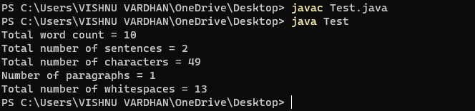

**Program 2**

class Customer{

int amount=10000;

synchronized void withdraw(int amount)

{

System.out.println("going to withdraw...");

if(this.amount<amount)

{

System.out.println("Less balance; waiting for deposit...");

try

{

wait();

}

catch(Exception e)

{}

}

this.amount-=amount;

System.out.println("withdraw completed...");

System.out.println(amount);

}

synchronized void deposit(int amount)

{

System.out.println("going to deposit...");

this.amount+=amount;

System.out.println("deposit completed... ");

notify();

}

}

class TestIC{

public static void main(String args[]){

final Customer c=new Customer();

new Thread()

{

public void run()

{

c.withdraw(15000);

}

}.start();

new Thread()

{

public void run()

{

c.deposit(10000);

}

}.start();

}

}

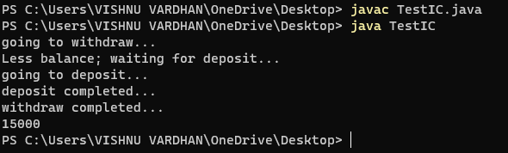

**Program 4**

import java.io.*;

import java.util.*;

public class Solution

{

public static void main(String[] args) {

String str1, str2;

Scanner sc =new Scanner(System.in);

System.out.println("Enter the first string : ");

str1=sc.nextLine();

System.out.println("Enter the Second string : ");

str2=sc.nextLine();

if(str1.length() != str2.length()){

System.out.println("Second string is not a rotation of first string");

}

else {

str1 = str1.concat(str1);

if(str1.indexOf(str2) != -1)

System.out.println("Second string is a rotation of first string");

else

System.out.println("Second string is not a rotation of first string");

}

}

}

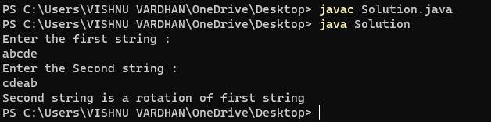

**Program 3**

import java.util.*;

class fizz

{

public static void main(String[] args)

{

try

{

int n;

Scanner sc=new Scanner(System.in);

System.out.println("Enter the value");

n=sc.nextInt();

if (n%5==0 && n%3==0)

System.out.println("FizzBuzz");

else if (n%5==0)

System.out.println("Buzz");

else if (n%3==0)

System.out.println("Fizz");

else

System.out.println("Enter a number divisible by 3 or 5");

}

catch(Exception e)

{

System.out.println("Due to character exception");

}

}

}

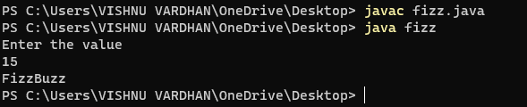

**Program 5**

class PrimeExample implements Runnable

//extends Thread

{

public void run()

{

int i,m=20,flag=1;

for(i=1;i<=m;i++)

{

if(i<=3){

System.out.println(i + " is prime number");

continue;

}

else if(i>3)

{

for(int j=2;j<i;j++)

{

if(i%j==0)

{

flag=0;

break;

}

}

if (flag!= 1)

{

System.out.println(i + " is not prime number");

flag=1;

}

else

System.out.println(i + " is prime number");

}

}

}

}

class prime

{

public static void main(String args[]){

try

{

PrimeExample p1 = new PrimeExample();

Thread t1= new Thread(p1);

t1.start();

}

catch(Exception e)

{

System.out.println(e.getMessage());

}

}

}

